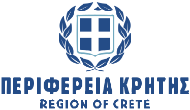
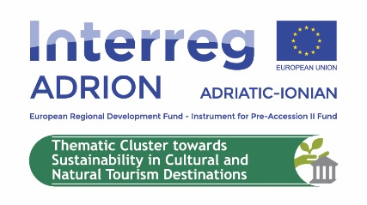
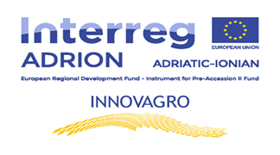

Chania 05/10/2020
The 2nd Cluster Meeting & Joint Stakeholders Meeting organised by Region of Crete in Chania at 2nd & 3rd of October 2020
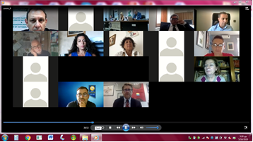
The 2nd Meeting of the Thematic Cluster No3: “Towards sustainability in cultural and natural tourism destinations” organised with a great success by the Region of Crete, as partner of INNOVAGRO project involved in this Thematic Cluster, in Chania at 2nd & 3rd of October 2020, in the framework of Adrion Programme Capitalisation activities.
The event took place at the premises of Mediterranean Agronomic Institute of Chania in a hybrid way (face to face and virtually as well) accompanied with an open Joint Stakeholders Meeting.
The main aim of the Thematic Cluster No3 established by the partnerships of the 7 Adrion Projects is to promote synergies among them and increase the transferability of their project results beyond the single project partnership in the field of the sustainable tourism.
During the 2nd Thematic Cluster Meeting a very fruitful and productive discussion was conducted regarding the main aim and activities of this Thematic Cluster with the participation of over 20 representatives from the Adrion J/S and the following Adrion projects: INNOVAGRO, INNOXENIA, QNeST, ADRION 5 SENSES, SMART HERITAGE, & APPRODI involved in this Cluster.
The event was accompanied with an open Joint Meeting with over 40 stakeholders who expressed their strong interest to be informed about the main aims and activities of the Thematic Cluster and involved in the scheduled capitalisation activities.
Finally, the 2nd day the members of the Cluster designed in more details the content of the Thematic Cluster’s main outputs based on the feedback received during the Joint Stakeholders Meeting.

